Answer questions, drawing on your knowledge, the textbook, speaking notes, my video presentations and other resources including online resources. Respond to each part of each questions you choose to answer. Put you name on your work. Submit your work (as a Word or Adobe pdf file) on or before the due date in GaVIEW. Type into the boxes on this Word file and expand the boxes as needed.

1. On August 10, 2020 I took the following picture of the debt clock available here:
http://www.usdebtclock.org/

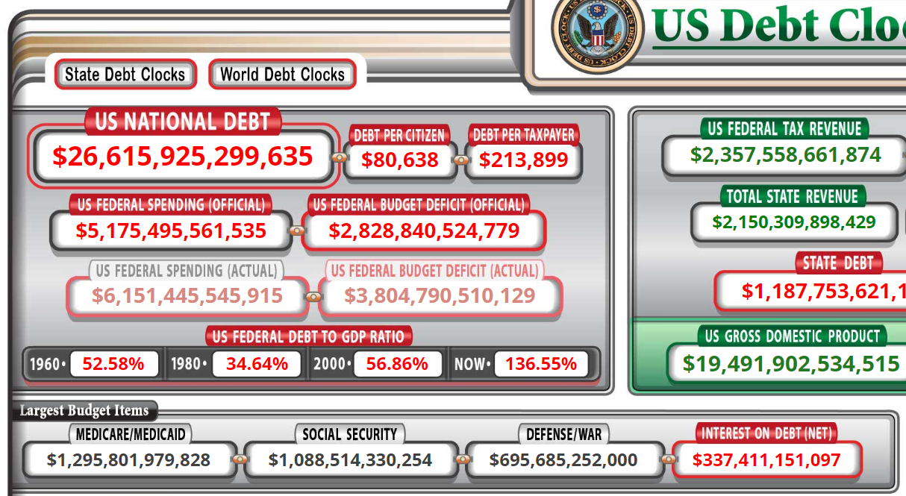

By how much has the US national debt increased since August 10, according to the "debt clock."

$1,187,753,100

Given that interest payments on the national debt are among the largest budget items in the US National Budget, what are the implications for intergovernmental transfers of money from the national government to state and local governments in coming years?

It will mean that the national government will be left with fewer finances to fund its operations. Also the local government may become lazy in finding their own sources of funds and hence overstretch the national government spending. They country will likely increase its current national debt to much huger figures. It will in the end pay more interest for the dent in terms of interest. Essentially the Debt per citizen will increase and consequently the debt per taxpayer will most certainly go up.

Are interest payments on the national debt discretional or nondiscretionary? What would be the consequence if the national/federal government of the United States simply refused to continue paying interest payments on the national debt? (Keep in mind that the Treasury Department of the U.S. government is continually having to refinance debt instruments as they come due, and also has to issue new debt instruments to pay for additional new expenditures.)

The interest paid on the national dent are non-discretional. That means it is compulsory for the government to pay interest on loans that it acquires. It is important for the government to put in mind that any borrowing will be subjected to interest and thus the need to spend the borrowed money in the most appropriate manner to save the taxpayers money. Also the instruments it uses to gain funding should be considerable in terms of the interest payable upon them. Expensive debt financing should be avoided at all costs as they will burden the nation with escalate interest rates.

Given the increase in the U.S. national debt from August 2020 (above) and what it is today, what do you estimate will the national debt will be three years from now?

It will certainly increase to over $2,000,000,000 in three years’ time

2. Please read this news report.

https://www.albanyherald.com/features/city-of-albany-faces-234-million-sewer-nightmare/article_ec75b7d6-97a4-11ea-aa37-3709c1551710.html

In 1954 (then) Albany City Manager Carey Burnett estimated the costs of correcting serious problems with the sewage disposal system to be about $4 million dollars. The problems were not corrected. The presently estimated costs to correct Albany's sewer system is over $200 million dollars.

In terms of politics and public budgeting, why was this problem not corrected years ago?

Lack of political goodwill and postponing of the critical issue has led to the heighted sewage correction cost.

Reflect on the contents of the news report above, including the following statement by one of our City Commissioners.

“We’re talking about projects that, together, might add up to around $3 million-$4 million,” he said. “While that might not seem like much with a number like $234 million hanging over our head, it’s the kind of thing we have to do. We have to take a 10- to 20-year approach on getting this done.”

Our City Administrator has identified loans and government grants as possible sources of the revenues needed.

It seems to be unlikely under present fiscal circumstances that the national government or the government of the state of Georgia is going to provide a grant large enough to rework the city's sewer system as it should be reworked.

If you were a banker or an independent investor, would you loan the City of Albany $200 million or more to permanently rebuild the sewer system and stop spilling sewerage into the Flint river? Why or why not?

Yes, as a banker or as an independent investor, it would be certainly important to permanently build the sewer system. This will protect the funds from misuse at the state level where there are vested interest from the politicians who may jeopardizes a swift correction of the sewer. Building the sere will itself cut unnecessary cost rather than granting the government the funds. Self-initiation of correcting the situation will run much faster to bring an end to marine death as a result of the spillage. With a quick fixing of the problem will bring about a sound marine life that is beneficial to both the locals as it will serve ae a source of their livelihood via fishing. As well the government will stand a greater chance of getting tax from the fishermen and boost the state economy of Georgia.

NB: Hello my friend. Remember to delete this part before you submit your work.
Please take a look at this work and see if it meets your expectations. If so, I request you to kindly remember to release the funds on time and leave a 10-star rating if you do not mind. I will really appreciate it. Also, you can find me on this mail (davykikuvi774@gmail.com) for more work in future if you will need my services. Feel free and let me know. I will always be at your service whenever I can. Again, thank you for working with me.

